**MONGODB ASSIGNMENT 3**

**1 Total sales per product.**

db.sales.aggregate([{$group:{_id: ”$product”,totalSales:{$sum:{multiply:[“price”,”quantity”]}}}}])

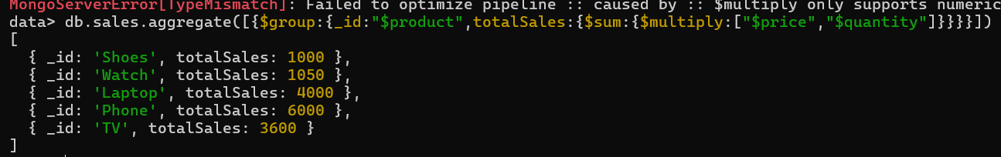

**2 Total revenue per product this do sum of all products**

db.sales.aggregate([{$group:{_id:"product",totalRevenue:{$sum:{$multiply:["$price","$quantity"]}}}}])

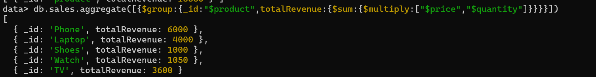

**3 Total revenue per category.**

db.sales.aggregate([{$group:{_id:"$category",totalRevenue:{$sum:{$multiply:["$price","$quantity"]}}}}])



**4 Count of products per category.**

db.sales.aggregate([{$group:{_id:"$category",count:{$sum:1}}}])



**5 Store-wise total sales.**

db.sales.aggregate([{$group:{_id:"$store",totalSales:{$sum:{$multiply:["$price","$quantity"]}}}}])

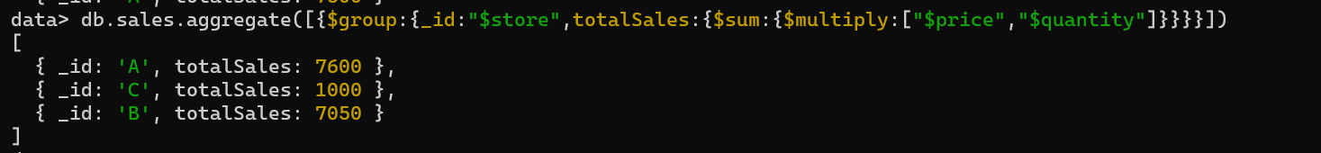

**6 Average price of products per category.**

db.sales.aggregate([{$group:{_id:"$category",avgPrice:{$avg:"$price"}}}])

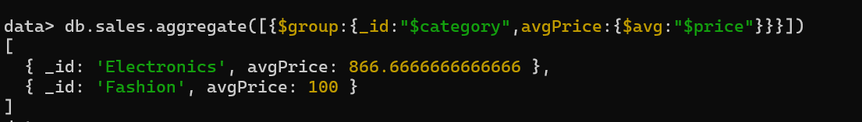

**7 Top-selling product**.

db.sales.aggregate([{$group:{_id:"$product",totalSales:{$sum:"$quantity"}}},{$sort:{totalSales:-1}},{$limit:1}])



**8 Total sales for Electronics category**.

db.sales.aggregate([{$match:{category:"Electronics"}},{$group:{_id:"Electronics",totalSales:{$sum:{$multiply:["$price","$quantity"]}}}}])



**9 Sales trend over time (day-wise total sales).**

db.sales.aggregate([{$group: {_id: { $DateToString: { format: "%Y-%M-%D", date: "$date" } },totalsales: { $sum: { $multiply: ["$price", "$quantity"]}}}])



**10 Highest revenue-generating product.**

db.sales.aggregate([{$group:{_id:"$product",totalRevenue:{$sum:{$multiply:["$price","$quantity"]}}}},{$sort:{totalRevenue:-1}},{$limit:1}])



**11 Average revenue per sale.**

db.sales.aggregate([{$project:{sales:{$multiply:[“$price”,”$quantity”]}}},{$group:{_id:”category”,avgSales:{$avg:”sales”}}}])



**12 Sales performance per store.**

db.sales.aggregate([ { $group: { _id: "$store", totalsales: { $sum: { $multiply: ["$price", "$quantity"] } } } }] )

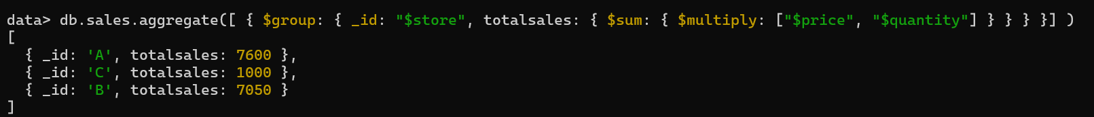

**13 Products sold more than 5 times.**

db.sales.aggregate([{$group: {_id: "$product",totalSales: { $sum: "$quantity" }}},{$match: { totalSales: { $gt: 5 } }}])

**14 Least sold product**.

db.sales.aggregate([{$group: {_id: "$product",totalSales: { $sum: "$quantity" }}},{$sort: { totalSales: 1 }},{$limit: 1}])



**15 Monthly sales summary.**

db.sales.aggregate([{$group: {_id: { $dateToString: { format: "%Y-%m", date: "$date" } },totalSales: { $sum:{ $multiply: ["$price", "$quantity"] } }}}])



**16 Number of unique products sold.**

db.sales.aggregate([{$group: {_id: "product",uniqueProducts: { $addToSet: "$product" }}},{$project: {uniqueProducts: { $size: "$uniqueProducts" }}}])



**17 Maximum and minimum priced product**

db.sales.aggregate([{$group: {_id: "price",maxPrice: { $max: "$price" },minPrice: { $min: "$price" }}}])



**18 Total revenue per product in descending order.**

db.sales.aggregate([{$group: {_id: "$product",totalRevenue: { $sum: { $multiply: ["$price", "$quantity"] } }}},{$sort: { totalRevenue: -1 }}])

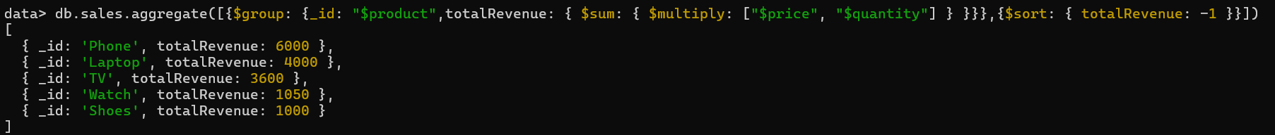

**19 Revenue generated per store per category.**

db.sales.aggregate([{$group: {_id: { store: "$store", category: "$category" },totalRevenue: { $sum: { $multiply: ["$price", "$quantity"] } }}}])

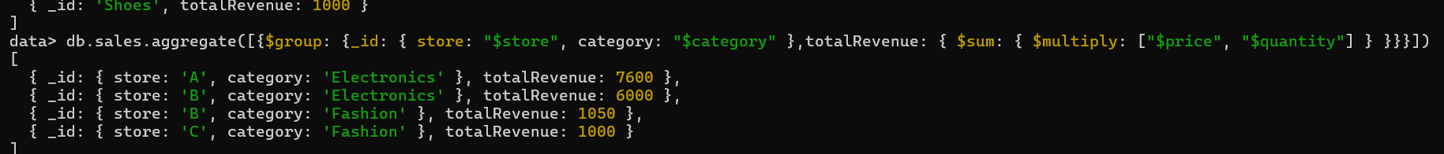

**20 Products contributing more than 50% revenue.**

db.sales.aggregate([{$group: {_id: "$product",productRevenue: { $sum: { $multiply: ["$price", "$quantity"] } }}},{$group: {_id: null,totalRevenue: { $sum: "$productRevenue" },products: { $push: "$$ROOT" } // Keep all products in an array}},{$unwind: "$products"},{$match: {"products.productRevenue": { $gt: { $multiply: ["$totalRevenue", 0.5] }}}}])

